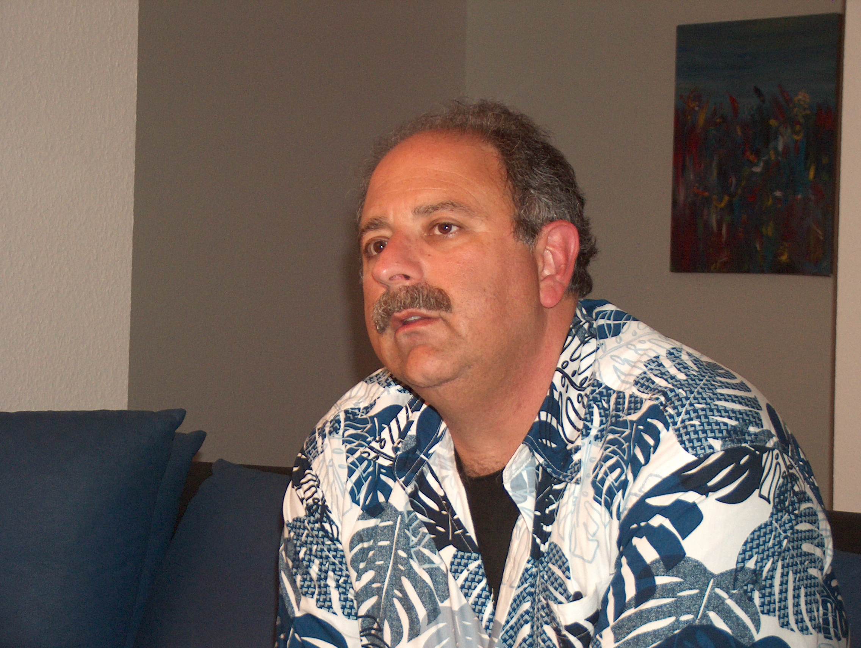
DON’T DO THAT:

SUPPORT YOUR SUPPLIERS
AND CONTRACTORS
By: Gary A. Minker

If you are in the Broadcast Engineering business as an employee or contracting member of the Gainfully Self Unemployed, you are probably over the age of majority and are not too crazy about folks shaking their finger at you bellowing, Don’t Do That!!

Get over it. It is these well meaning folks that are either trying to save you from killing yourself, your apprentice, or the station cat, and in this well meaning insubordination, you ought to listen to what they have to say and not just write it off as their childish folly. Those older, and some younger, may have been to the goat roping that you missed and in this series of articles, I will be that thorn in your side and welcome your thoughts by Email or voice toward the same content.

I realize that many things related to your employment are actually out of your control. There is no shame in this and even as the Filet de Sole of your own consulting debacle in today’s tide of thriftiness, no one is spending any money. This Scrooge attitude is well meaning and is designed to supposedly save your job, the company and the owners bottom, but you have to realize that in this interlinked global economy in your Town, County or State, your penny saved is NOT someone else’s penny earned, and as sorry as the economy is today, that penny could make or break someone that you do business with.

If you are a forward thinking person, you have a stock of the items that you use or consume. I imagine with the austerity program going in to its 4th year that your stock of spare rolls of solder is getting low. You might want to think of buying just one of something small from each of your suppliers, and you will stay on their Christmas Card list. You are not cleaning things like you should. You are not running proof of performances like you should. You are not testing antennae and lines to ward off evil spirits. You run tubes way passed end of filament life. You don’t change filters regularly. I can keep it up, and I know you get the picture, but the hazard to you directly is that these shameful iterations of YOU, only make YOU look like “you” are not doing your job to the suit up front. He or she may not like it, but the reality needs to set in some time that it really does cost money to run this show and the longer they tell you no, and you keep making it happen without protest, the more they prove you wrong and the worse this budget slicing will get in this inch for a mile thing.

Even if you feign to be doing your job with the few pence the suit up front gives you, this hoarding of pennies goes even farther to damage the economy and your security.

Radio Works R.F. Consulting 7225 Catalina Isle Drive Lake Worth, Florida 33467
Office ( 561 ) 969-9245 Email Gary@Radioworksrfconsulting.com
The information contained in this communication is considered to be Work Product and has an imputed value.
Reproduction or dissemination of this information is prohibited without compensation to the author

That Penney you are not spending can save your local store, eatery, supplier and shamefully, yes, your consultants. Times are hard and while few are sending Christmas cards, that Penney, or just one purchase or P.O. per year can save a trusted associate, so that when you NEED them, they will still be here to help you.

Yes, this flies in the face of the edict in the last memo you got but we all have to start somewhere. The toughest vendor may not be the best, and the survivors of this rock squeezing may not be the one that you prefer, so it is up to all of us to help insure that we all survive and not run each other out of business. If you can not pry that Penney loose, call your suppliers now and then to let them know they still matter and that when things get better, they will be tops on your hit parade. Next time the boss asks why you want the money to do something, tell him that it is important and why, and when he complains about it, stand up and tell him, Don’t Do That.

